Experiment Number : 8 Date: 18-02-2026

Implementation of Packages in Java

Aim:
Write a Java program to implement built-in, user-defined packages and accessing all classes in a package.

PRE LAB EXERCISE
QUESTIONS
- What is java.util package and what collection framework does it contain?
- A built-in Java package called 1.java.util offers utility classes for managing data and standard operations.
- It contains the Collection Framework, which is used to store and manage groups of objects. It contains classes like Array List, LinkedList, HashSet, HashMap, TreeMap, and interfaces like List, Set, Queue, and Map.
- What are the two types of packages in Java?
- Built-in Packages: Java offers predefined packages, such as java.lang, java.util, and java.io
- .User-defined Packages: These are packages made by programmers who arrange classes using the package keyword.

IN LAB EXERCISE
Objective
To understand and implement the concepts of built-in, user-defined packages and accessing all classes in a package in Java.
Built-in Packages comprise a large number of classes that are part of the Java API. Some of the commonly used built-in packages are:
Many of the classes that make up the Java API are contained in built-in packages. Among the frequently utilized built-in packages are:
Classes that define primitive data types and math operations are among the language support classes found in java.lang. It imports this package automatically.
Classes for facilitating input/output operations are contained in java.io.
Classes for facilitating input/output operations are contained in java.io.
• java.util: Provides date and time operations and utility classes that implement data structures like dictionaries and linked lists.
Classes for making Applets are contained in the java.applet file.
Classes for implementing the elements of graphical user interfaces, such as buttons, menus, etc., are contained in java.awt.

Source Code
import java.util.Random; // built-in package
public class Sample{
public static void main(String[] args) {
// using Random class
Random rand = new Random();
// generates a number between 0–99
int number = rand.nextInt(100);
System.out.println("Random number: " + number);
}
}
Output

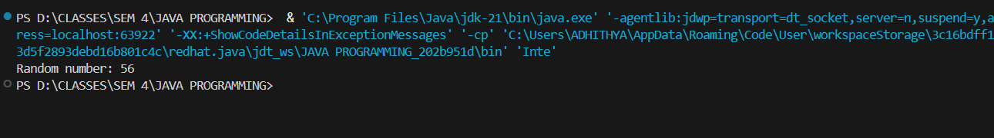
User-defined Packages are the packages that are defined by the user.
Source code
package com.myapp;
public class Helper {
public static void show() {
System.out.println("Hello from Helper!");
}
}
==To use this in another class==
import com.myapp.Helper;
public class Test {
public static void main(String[] args) {
Helper.show();
}
}

Output:
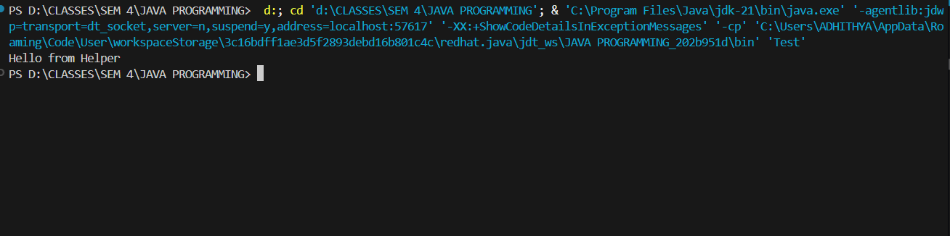
//Importing all classes from a package.
Source code
import java.util.Vector;
public class Coders {
public Coders() {
// java.util.Vector is imported, We are able to access it directly in our code.
Vector v = new Vector();
java.util.ArrayList l = new java.util.ArrayList();
l.add(3);
l.add(5);
l.add(7);
System.out.println(l);
}
public static void main(String[] args) {
new Coders();
}
}
Output
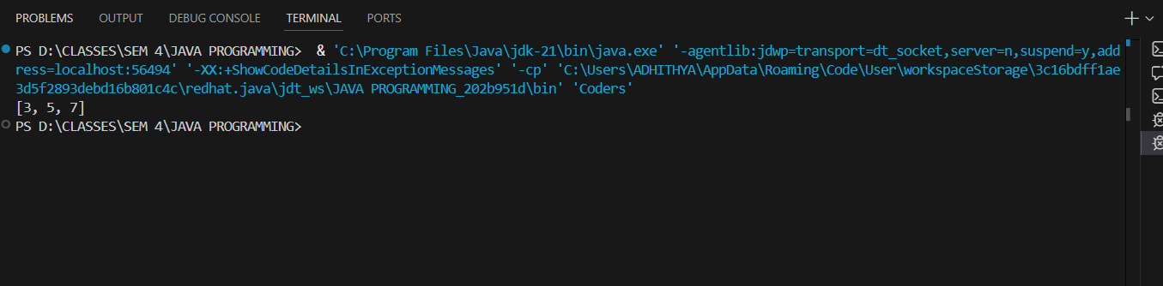
POST LAB EXERCISE
- What will happen if two classes in different packages have the same name and are imported in a Java file?
It creates a compile-time ambiguity error because the compiler cannot decide which class to use.
To resolve this, you must use the fully qualified name (e.g., packageName.ClassName) instead of importing both.
- What is the purpose of using packages in Java?
Packages are used to:
- Organize related classes and interfaces into groups
- Avoid naming conflicts
- Provide better access control
- Improve code management and reusability

- Which built-in Java package would you use if you want to create a GUI window and display a message?
- java.util
java.util package contains utility classes for data structures, date & time, random numbers, and more.
- java.sql
java.sql package provides classes and interfaces for database connectivity (JDBC).
- java.awt
java.awt stands for Abstract Window Toolkit.
It is used for GUI (Graphical User Interface) development.
- java.net
java.net package is used for network programming.
C. java.awt
It contains classes like Frame, Label, and Button used to build GUI applications.

ASSESSMENT

Description | Max Marks | Marks Awarded
Pre Lab Exercise | 5
In Lab Exercise | 10
Post Lab Exercise | 5
Viva | 10
Total | 30
Faculty Signature

